* What is the difference between executable type program and module type program?
  + Executable type program usually used for creating a program, for displaying a report while module pool type program usually used for creating a transition program such as program for creating purchase, order, service, order and so on.
* Module type program consist of one or more screen and the screen consist of elements such as label input, output, field button, radio button, their sub screen and so on.
* And if you want to execute a module pool type program, we have to create a transaction called first.

Now we start creating a module pool type program for creating student.

We open transaction se80 and then we create a program.

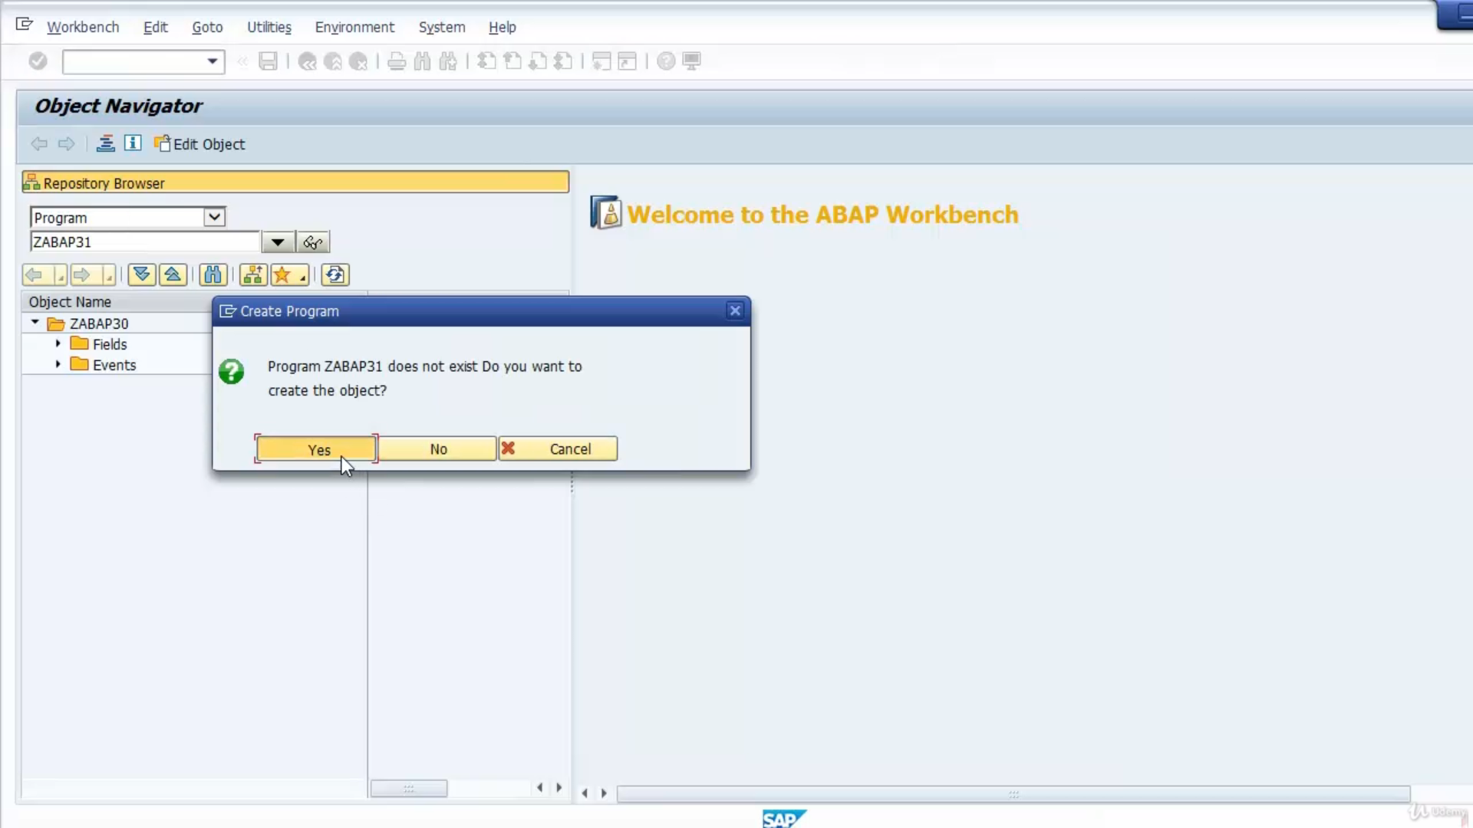

we create the top include, program type is automatically set to module pool.

We save and activate the program.

And then we open the program, we see the top include is already created beside top include SAP recommends as to create another includes the include suffix O01 for storing processed before output codes of screen and then include we had suffix I01 for storing process after input codes of screen and then include with suffix F01 is for storing subroutines.

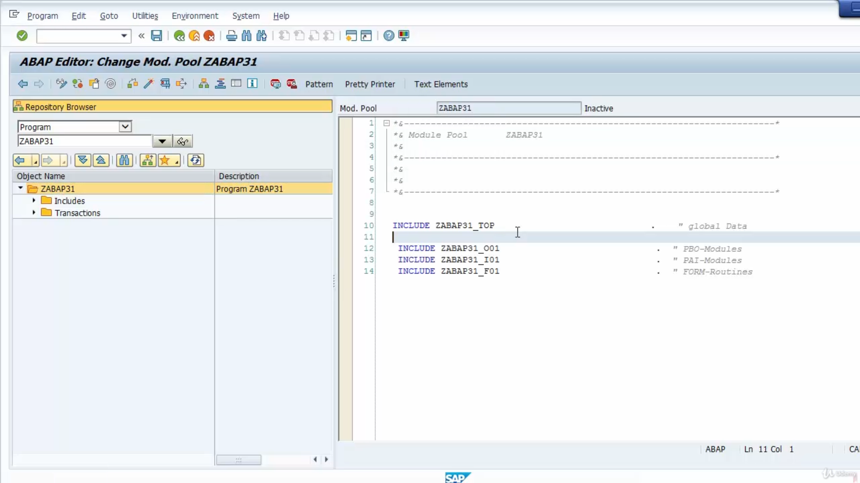

And then we create a screen with number one hundred, the number of screen is up to us.

We fill description field.

The element list tab contains the elements on the screen, we have not added elements on the screen, but by default there is ok code element this will get OK there is triggered by a user and then the flow logic contains the logic for the screen.

It contains two sections process before output or PBO, all this logic is executed before the screen is displayed.

And then the second is process after input or PAI, this logic is executed after the user interaction, such as inputting data to an input output field, pressing a button on the screen and so on.

OK, now we add elements on the screen.